Rt 68
TRANSMISSION CORPORATION OF ANDHRA PRADESH LIMITED
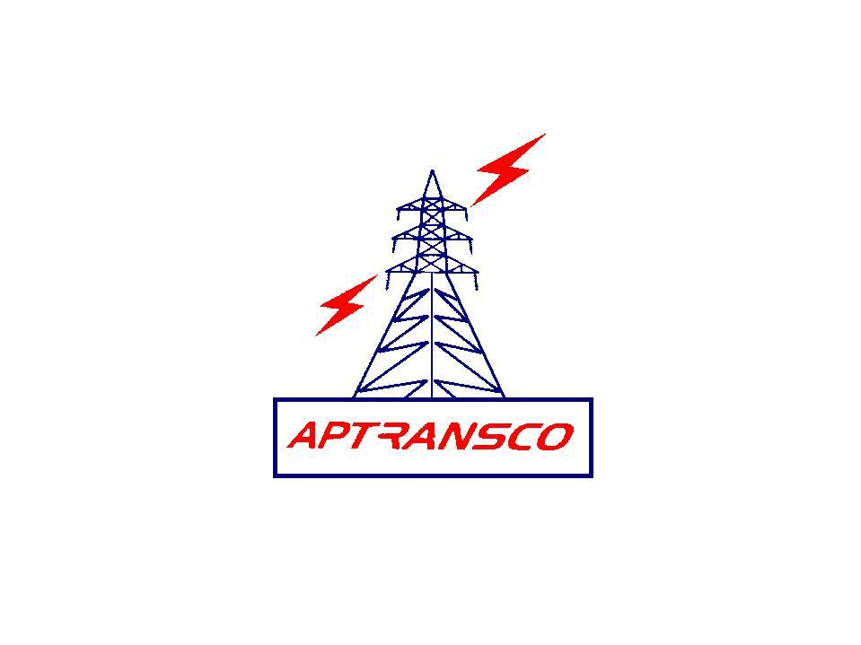
O/o.Chief Engineer, Rural Zone, A.P.TRANSCO, 220KV SS, GTS Colony, Erragadda, Hyderabad

Memo.No.CE/RZ/HYD/AS/PO-II/JPO/F.No.E.L./D.No.2802/13, Dt:18/11/2013

Sub:- Estt., - APTRANSCO – G.S. – Smt.I.Rajeshwari, OS, O/o.CE/Rural Zone – Earned Leave Sanctioned – Reg.

Ref:- Earned Leave Application dtd.12/11/2013 of Smt.I.Rajeshwari, OS.

& & &

Under Regulation 16 of APSE Board Leave Regulations as adopted by APTRANSCO Smt.I.Rajeshwari, O.S, O/o.CE/Rural Zone/Hyderabad working under the control of Senior Accounts Officer/Rural Zone is sanctioned Earned Leave for 11 days from 01/11/2013 FN to 11/11/2013 AN on private affairs.

2. She is permitted to draw the usual pay and allowances as admissible during the above leave period.

3. It is to certify that but for her proceedings on leave, she would have to continue to officiate as Office Subordinate during the above leave period.

4. On Expiry of leave she is deemed to have been posted back to the control of Senior Accounts Officer O/o.CE/RZ/Hyderabad where she re-joined duty as OS on 12.11.2013 FN.

5. She is having 183 days balance of Earned Leave at her credit after sanction of the above leave.
R. NAGARAJA SWAMY
CHIEF ENGINEER,
RURAL ZONE/HYDERABAD.
To
Smt.I.Rajeshwari, OS
Through Senior Accounts Officer/Rural Zone/Hyderabad
Copy to
The Senior Accounts Officer/Rural Zone/Hyderabad
The Accounts Officer/TL&SS/Sangareddy
Stock file || PF || ERP
// FORWARDED :: BY ORDER//
PERSONNEL OFFICER

